|  |
| --- |
| IOM |
| Travel Authorization System | |
| User Manual |

Table of Contents

1 Revision History 3

2 Glossary 3

3 General information 4

3.1 System Overview: 4

3.2 System Requirements: 4

4 GETTING STARTED: 4

4.1 Logging On: 4

4.2 Main Screen: 5

4.2.1 Header Bar / Log Out 5

4.2.2 Main Menu 6

4.2.3 Output window 6

5 USING THE SYSTEM 7

5.1 Session Timeout 7

5.2 Mandatory Fields 7

6 Using the system 8

6.1 Screens usage 8

6.1.1 Travel Authorization-My Travel Authorizations screen 8

6.1.1.1 Travel Authorization-My Travel Authorizations screen access 8

6.1.1.2 Travel Authorization-My Travel Authorizations screen usage 9

6.1.2 Travel Authorization-Search Travel Authorization screen 13

6.1.2.1 Travel Authorization-Search Travel Authorization screen access 13

6.1.2.2 Travel Authorization-Search Travel Authorization screen usage 14

6.1.3 Travel Authorization – Search Staff Member TA 15

6.1.3.1 Travel Authorization – Search Staff Member TA screen access 15

6.1.3.2 Travel Authorization - Manager Travel Authorizations Search screen usage 16

List of Figures

Figure 1 - TAS Login Screen 4

Figure 2 - Main Screen 5

Figure 3 - TAS Header Bar Button 5

Figure 4 - Main Menu 6

Figure 5 - Home Screen 6

Figure 6 - Mandatory Fields 7

Figure 7 - Travel Authorization-My Travel authorizations screen access 8

Figure 8 - Travel Authorization-My Travel authorizations screen 8

Figure 9 - Travel Authorization Form screen 9

Figure 10 – Moving Between Steps 9

Figure 11 – Modifying Values 10

Figure 12 – DSA Breakdown Access 10

Figure 13– DSA Breakdown Window 10

Figure 14 – Check List 11

Figure 15– Change Status 11

Figure 16– Duplicate TA 11

Figure 17– Duplicate TA Window 12

Figure 18– Add Staff Members 12

Figure 19– My Travel Authorizations 12

Figure 20 - Travel Authorization-Search Travel Authorization screen access 13

Figure 21 - Travel Authorization-Search Travel Authorization screen 13

Figure 22 - Search Travel Authorization Screen 14

Figure 23– Travel Authorization – Search Staff Member TA screen access 15

Figure 24 - Travel Authorization - Search Staff Member TA screen 15

Figure 25 – My Travel Authorizations 16

# Revision History

|  |  |  |  |
| --- | --- | --- | --- |
| **Version** | **Date** | **Name** | **Changes** |
| 1.0 | August 21, 2016 | AHMAD, Dana | Initiated the document. |
| 1.1 | October 19, 2016 | AHMAD, Dana | Updated the document. |
| 1.2 | November 7, 2016 | AHMAD, Dana | Updated the document. |
| 1.3 | December 4, 2016 | AHMAD, Dana | Updated the document. |
| 1.4 | September 11,2017 | Al Za’atreh, Mohammad | Updated the document. |
| 1.5 | December 13, 2017 | AYOUB, Natali | Updated the document. |
| 1.6 | January 8, 2018 | AYOUB, Natali | Updated the document. |
| 1.7 | January 14, 2018 | AYOUB, Natali | Updated the document. |
| 1.8 | April 11, 2018 | AYOUB, Natali | Updated the document. |

# Glossary

|  |  |
| --- | --- |
| **Term** | **Meaning** |
| IOM | **I**nternational **O**rganization for **M**igration |
| TAS | **T**ravel **A**uthorization **S**ystem |
| TA | **T**ravel **A**uthorization |
| TEC | **T**ravel **E**xpense **C**laim |
| DSA | **D**aily **S**ubsistence **A**llowance |

# General information

## System Overview:

The Travel Authorization and Expense claim system reflects and streamline the current business processes of the Finance and Human Resources Units.

The system facilitates the submissions and calculation of TAs and TECs that will impact the delivery of service in an organized and timely manner.

The system provides access to all employees and enter their TA and TEC information and generate the necessary reports that is needed by the FIN and HR.

## System Requirements:

* Network access
* Internet Explorer 7.0 (or higher)

# GETTING STARTED:

This document prescribes the procedure of using TAS.

## Logging On:

The TAS is accessible through intranet. The users can use their windows credentials to access the system.

Enter the system URL on the address bar of you Microsoft Internet Explorer – browser to access TAS web webpage, then the system login screen appears.

* On the login screen, enter your username and password as shown in **Figure 1**.
* Click “Login” button.
* Once you are successfully logged in you will be redirected to the TAS home page.

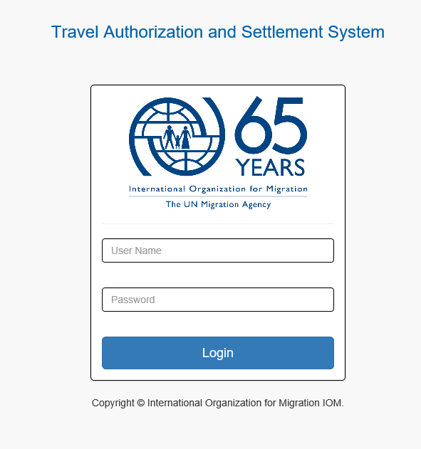

Figure - TAS Login Screen

## Main Screen:

The TAS home page appears upon successful log in. This screen and all system screens are divided into three sections: header bar, main menu and output window:

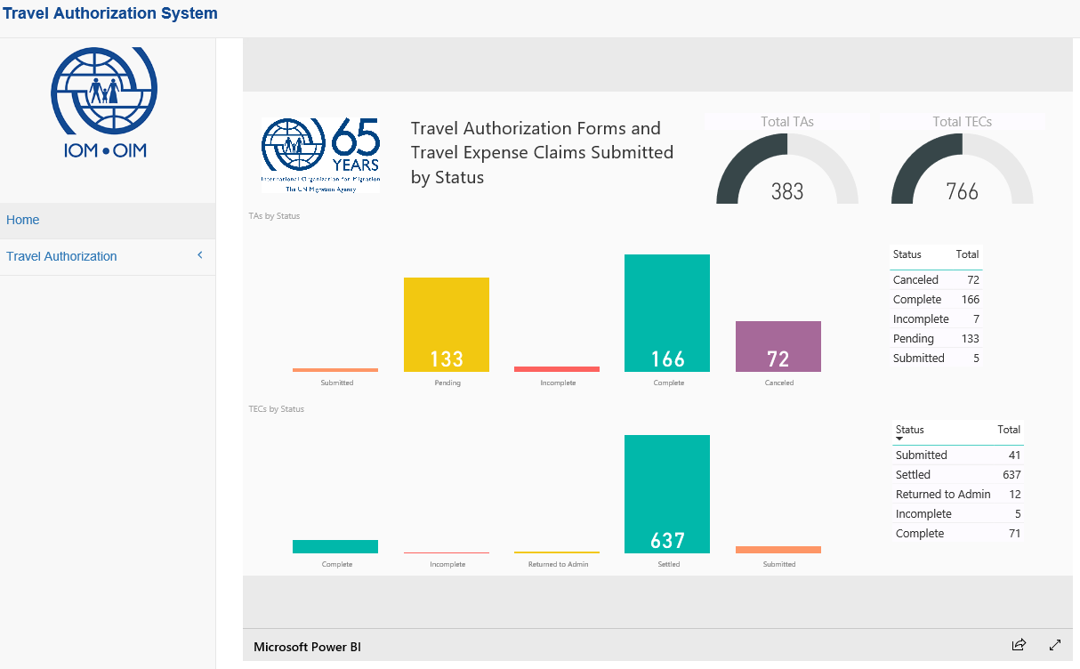

Figure - Main Screen

### Header Bar / Log Out

If you want to logout from the system you should click on the icon and a drop down will be shown, logout button is shown in all system pages, so you can logout from using any page.

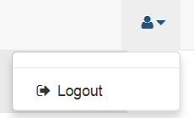

Figure - TAS Header Bar Button

### Main Menu

The left side of the main screen contains the main menu of all screens, these screens are viewed to user based on his/her permissions.

Once you click an item in the main menu a sub menu is opened allowing you to navigate all screens related to main menu item as shown below.

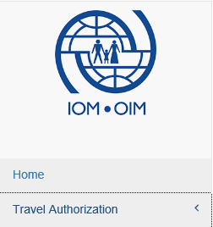

Figure - Main Menu

### Output window

Located in the middle of the main screen and containing a report for total of travel authorizations by status.

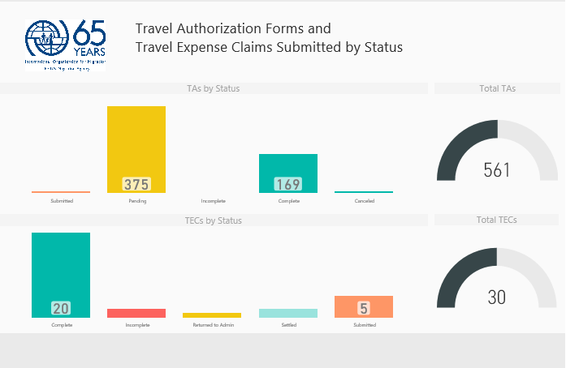

Figure - Home Screen

# USING THE SYSTEM

Below is a list of essential information to ensure effective usage while using the system.

## Session Timeout

* In order to keep a session active, you must perform a system function (e.g. clicking on a link or button, etc.) at least every thirty (30) minutes.
* You will be redirected to the Log In page if you click on a system function after your session has expired.

## Mandatory Fields

You must complete all mandatory fields in order to ensure a successful submission of data. The system detects whether a mandatory field is not populated with data. The mandatory field if not filled a red border will surround the field.

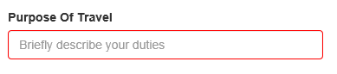

Figure - Mandatory Fields

# Using the system

## Screens usage

### Travel Authorization-My Travel Authorizations screen

#### Travel Authorization-My Travel Authorizations screen access

This screen can be accessed by clicking its menu item named “My Travel Authorizations” located under “Travel Authorization” menu.

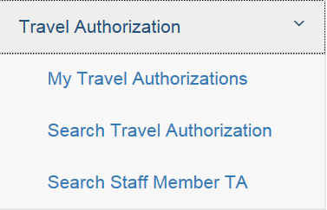

Figure - Travel Authorization-My Travel authorizations screen access

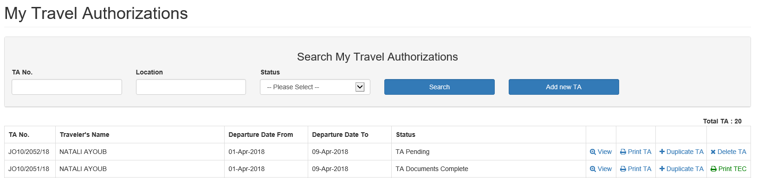

Figure - Travel Authorization-My Travel authorizations screen

#### Travel Authorization-My Travel Authorizations screen usage

1. To search for your travel authorizations, fill the search criteria and click “Search” button.
2. To add new travel authorization, click on “Add new TA” button then you will be redirected to “Travel Authorization Form”, **Figure 9.**

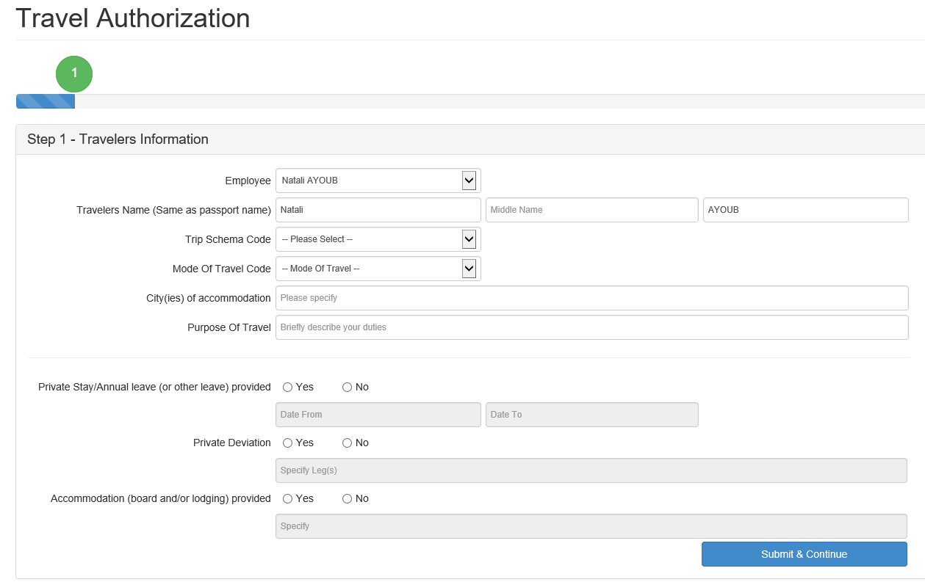

Figure - Travel Authorization Form screen

1. To move on to the next step, fill the required fields correctly and click on “Submit & Continue” and you will be redirected to the next step; the entire process ends in Step 10.

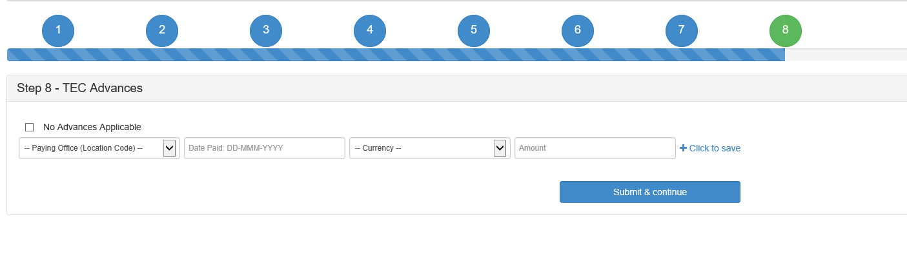

Figure – Moving Between Steps

1. To create a travel authorization form on behalf of another staff member (only valid if the user has a manager role):

* Choose the staff member name from the “Employee” drop down list, **Figure 9**, and the chosen name should be reflected in “Travelers Name” first and last field.

1. Step 5 allows you to download the TA form and it is only accessible if Step 1, 2, 3 and 4 are filled correctly.
2. Step 10 allows you to download the TEC form and it is only accessible if all other steps are filled correctly.
3. Click on “Click to save” to add values to the grid after filling the fields in steps 3 (WBS), 4 (Travel Itinerary), 7 (TEC Expenses) and 8 (TEC Advances) then click on “Submit & Continue” to save and move to the next step.
4. Click on “Click to edit” to edit any value from the grid or “Click to delete” to delete values.

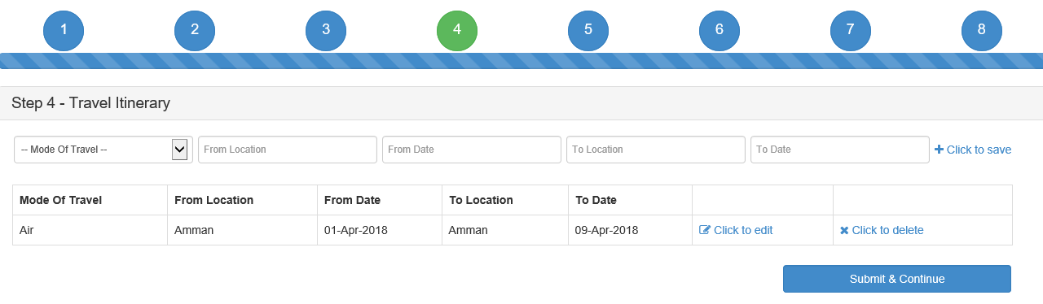

Figure – Modifying Values

1. To hide a TEC from the staff member, click on “DSA not Applicable” and the staff member will no longer see the TEC form. This is only available for Admin Staff.
2. DSA breakdown can be accessed in Step 6, by clicking on “DSA Breakdown”.

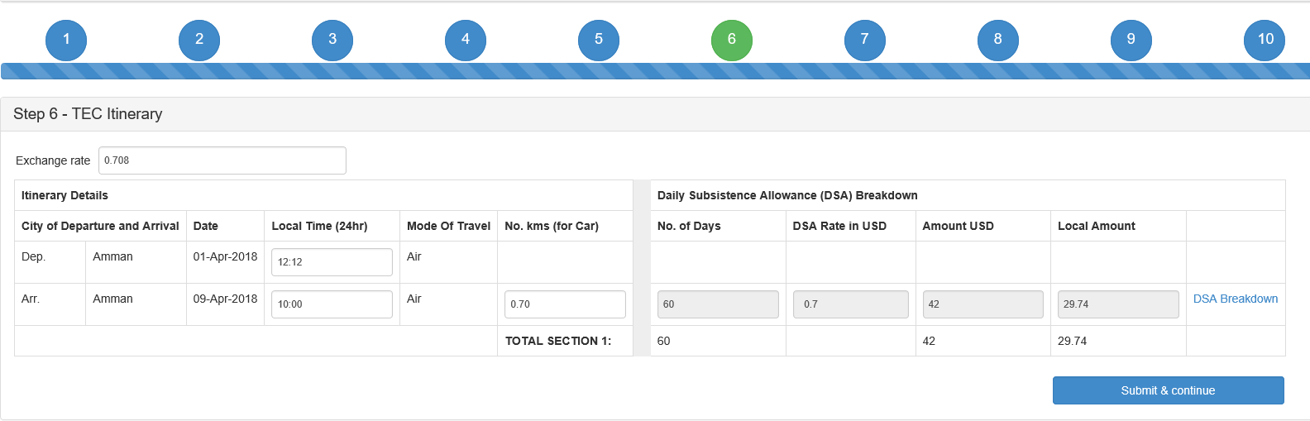

Figure – DSA Breakdown Access

Then DSA popup will appear, fill the required fields and click  button.

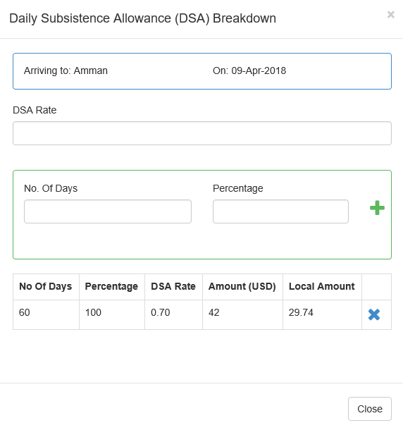

Figure – DSA Breakdown Window

1. To finalize the form and show the TEC report, the check list in Step 9 must be saved and it can only be saved if the last 4 check boxes are yes and the “I confirm the completeness of TEC” is checked.

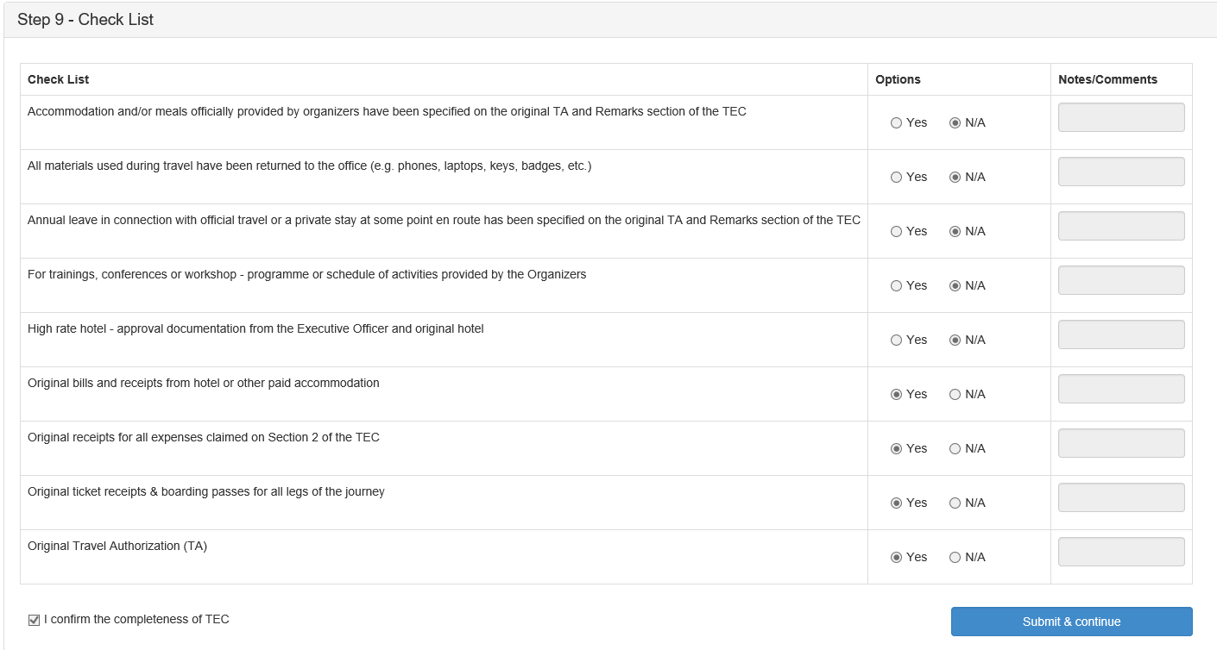

Figure – Check List

1. To change the status of the TA, choose a status from the drop down list then click on “Save”. To view history of the TA click on “View History”.

This is only available for Admin staff.



Figure – Change Status

1. To create duplicate TAs (this is only accessible for manager role), click on “Duplicate TA” in “My Travel Authorizations” page, **Figure 16.**



Figure – Duplicate TA

1. A pop up, **Figure 17**, will appear;

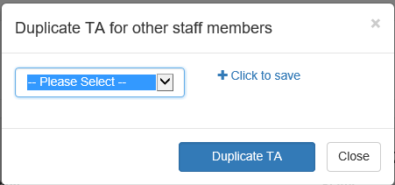

Figure – Duplicate TA Window

1. Select a staff member from the dropdown list then click on “Click to Save” and the chosen employees will appear in a grid as shown below.

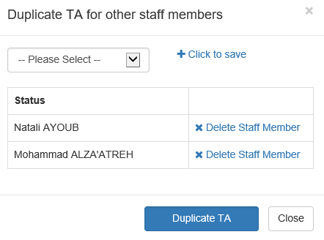

Figure – Add Staff Members

1. After choosing all staff members, click on “Duplicate TA” and new duplicate TAs will be created for each chosen staff member.
2. To edit your TA, click on “View” button next to the TA in “My Travel Authorizations” page, then the TA and TEC forms will show and can be edited.



Figure – My Travel Authorizations

1. To print the TA, click on “Print TA” and a PDF file of the TA will be downloaded.
2. To print the TEC, click on “Print TEC” and a PDF file of the TEC will be downloaded.
3. To delete pending TAs, click on “Delete TA” and the Ta will be deleted. This option is only available for TAs whose status is pending and only staff members can delete their own TAs.

### Travel Authorization-Search Travel Authorization screen

#### Travel Authorization-Search Travel Authorization screen access

This screen can be accessed by clicking its menu item named “Search Travel Authorization” located under “Travel Authorization” menu.

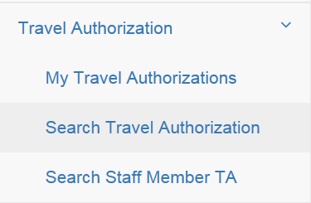

Figure - Travel Authorization-Search Travel Authorization screen access

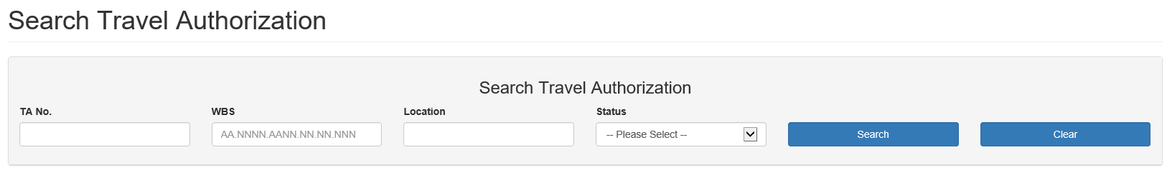

Figure - Travel Authorization-Search Travel Authorization screen

#### Travel Authorization-Search Travel Authorization screen usage

1. To clear the fields, click on “Clear”
2. To search for any travel authorization, fill the search criteria and click “Search” button.
3. To view TA and TEC, click “View” next to the TA you want to view then you will be redirected to “Travel Authorization Form” screen.
4. Click on “Print TA” to download a PDF file of the TA report.

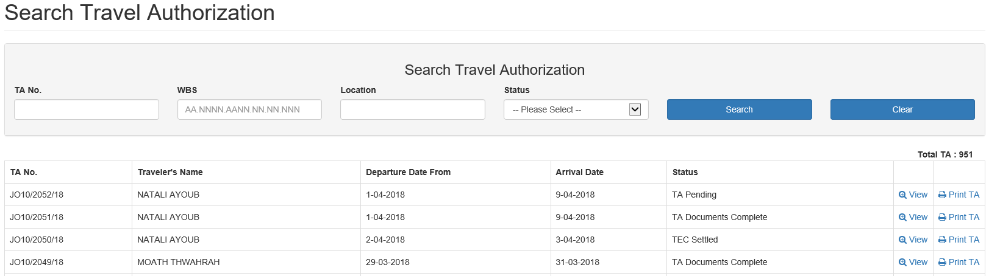

Figure - Search Travel Authorization Screen

### Travel Authorization – Search Staff Member TA

#### Travel Authorization – Search Staff Member TA screen access

This screen can be accessed by clicking its menu item named “Search Staff Member TA” located under “Travel Authorization” menu.

**\*This screen is only accessible by managers.**

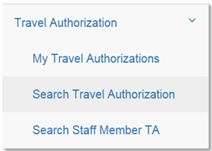

Figure – Travel Authorization – Search Staff Member TA screen access

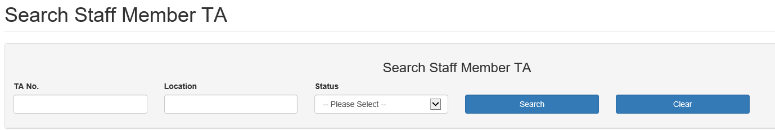

Figure - Travel Authorization - Search Staff Member TA screen

#### Travel Authorization - Manager Travel Authorizations Search screen usage

1. To clear the fields, click on “Clear”
2. To search for employee travel authorization, fill the search criteria and click “Search” button.
3. To edit your TA, click on “View” button next to the TA in “Search Staff Member TA” page, then the TA and TEC forms will show and can be edited.

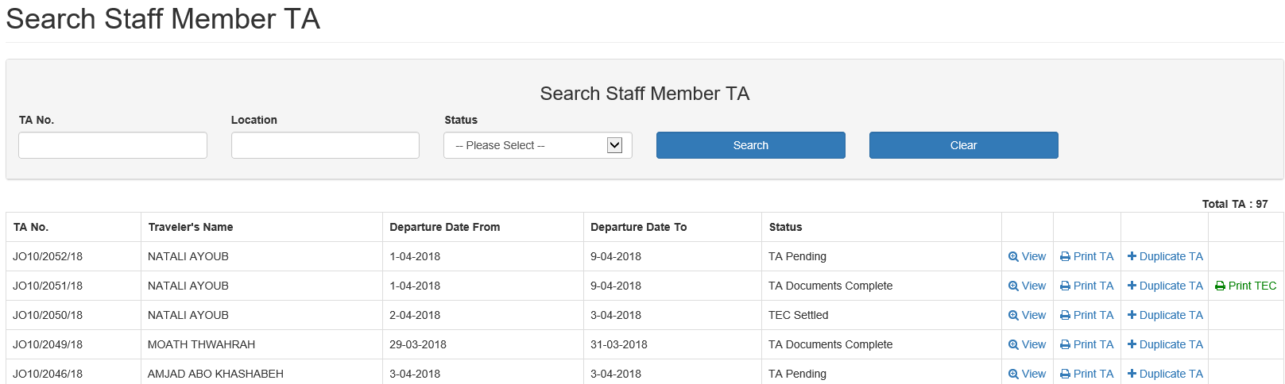

Figure – My Travel Authorizations

1. To print the TA, click on “Print TA” and a PDF file of the TA will be downloaded.
2. To print the TEC, click on “Print TEC” and a PDF file of the TEC will be downloaded.
3. To create Duplicate TAs, click on “Duplicate TA”.